Horizon Europe Framework Programme


OPTICAL 6G CELL-FREE NETWORKS

______________________________________________________

D2.3 OWC Cell-Free Network Testing and KPI Verification Methodology
Contractual Delivery Date: | 30-06-2025
Actual Delivery Date: | TBD
Editor: | Clément Lartigue, Oledcomm (OLED)
Deliverable nature: | Report
Dissemination level: | Public
Version: | 1.0
Keywords: Optical wireless communication, cell-free network, positioning, system architecture, building blocks, KPI, test-bed, test procedure, performances
ABSTRACT
This document presents the description of the multiple test-beds and experimental set-ups to validate the performance of the different KPIs. The document is providing a detailed description of the experimental set-ups in the lab and the expected results.

Disclaimer
This document contains material, which is the copyright of certain OPTI-6G consortium parties, and may not be reproduced or copied without permission.
The information contained in this document is the proprietary confidential and sensitive information of the OPTI-6G consortium and may not be disclosed except in accordance with the grant agreement and consortium agreement.
Neither the OPTI-6G consortium as a whole, nor a certain part of the OPTI-6G consortium, warrant that the information contained in this document is capable of use, nor that use of the information is free from risk, accepting no liability for loss or damage suffered by any person using this information.

This project has received funding from the European Union’s Horizon Europe research and innovation programme under grant agreement No 101139292. This publication reflects only the author’s view and the European Commission is not responsible for any use that may be made of the information it contains.

Impressum
Full project title: OPTICAL 6G CELL-FREE NETWORKS
Short project title: OPTI-6G
Number and title of the work package: WP2 – User Scenarios, Functional and Technical Requirements, System Architecture
Number and title of task: Task 2.3 – Testing and KPI Verification Methodology
Document title: D2.3 – OWC Cell-Free Network Architecture
Editor: Clément Lartigue, Oledcomm (OLED)
Work-package leader: Israel Koffman, RunEL

Executive summary

This deliverable presents a comprehensive set of guidelines for the testing configurations and methodologies to be used in the characterisation and validation of Key Performance Indicators within the scope of WP3 and WP4. It outlines the design and implementation of various test beds and experimental setups to be deployed in laboratory environments. These setups are aligned with the KPIs defined in earlier project tasks and are tailored to support the validation of both communication and localisation capabilities of the Cell-Free Optical Wireless Communication system. The document also details the complete test procedures required to evaluate system performance, ensuring consistency, repeatability, and reliability in experimental validation.

List of authors
Company | Author | Contribution
Oledcomm | Clément Lartigue | Editor
UVSQ | Bastien Béchadergue  Kevin Acuna-Condori | Contributors
Brunel | John Cosmas | Contributor
RunEL | Israel Koffman | Contributor

Document History
Version | Date | Editor | Description
0.1 | 11/03/2025 | Clément Lartigue | Document structure, initial inputs
0.2 | 06/05/2025 | John Cosmas  Israel Koffman  Bastien Bechadergue | Inputs on specific sections from each partner
0.3 | 13/05/2025 | Clément Lartigue | General formatting
0.4 | 13/05/2025 | Israel Koffman | RunELs sections update
0.5 | 19/05/2025 | Bastien Béchadergue  Kevin Acuna-Condori | UVSQ sections update
0.6 | 20/05/2025 | Clément Lartigue | Corrections in various sections + add RSS test setup description from Brunel
0.7 | 01/07/2025 | Rewievers | Review and comments
0.8 | 01/07/2025 | Audrey Bienvenu | Final editing and layout

Table of Contents
Executive summary 3
List of authors 4
Document History 4
Table of Contents 5
List of figures 6
Abbreviations and Acronyms 7
1 Description of the test environment 9
1.1 General description of the test beds 9
1.2 Communication test bed architecture 9
1.3 Localisation test bed architecture 10
1.4 Envisioned test bed implementation 11
1.4.1 TDoA localisation test setup 13
1.4.2 RSS localisation test setup 14
1.4.3 Beamsteering-based localisation test setup 28
2 KPI definition 32
2.1 KPIs for OWC communication 32
2.2 KPIs for localisation 33
2.2.1 TDoA localisation KPIs 33
2.2.2 RSS localisation KPIs 34
2.2.3 Beam-steered based localisation KPIs 34
3 Test procedures 36
3.1 Test procedures for cell free network KPIs testing 36
3.2 Test procedures for localisation KPIs testing 40
3.2.1 TDoA localisation test procedure 40
3.2.2 RSS localisation test procedure 41
3.2.3 Beam-steered based localisation test procedure 42
4 Integration Roadmap 45
4.1 Introduction 45
4.2 Measuring the Received Signal Strength of a LiFi Max system 45
4.3 Measuring the TDoA from a 5G sub-6GHz system 45
4.4 Integration Roadmap 46
5 Summary and Conclusions 47
6 References 48

List of figures
Figure 1 - OWC CFN experimental set-up. 9
Figure 2 - OWC test setup for localisation. 10
Figure 3 - Physical installation of the OWC TX (Red dot) and RX (Blue dots) antennas for proper TDoA localization and communication performance tests in the Brunel Lab (5 m x 2.5 m). 12
Figure 4 - Physical installation of the OWC TX and RX antennas (UE in the middle) for proper cell free performance tests in the Brunel Lab (5 m x 2.5 m). 13
Figure 5 - Proposed Modification. 16
Figure 6 - Optical Antenna [3]. 17
Figure 7 - RJ45 2-Way Splitter. 17
Figure 8 - RJ45 Connector. 18
Figure 9 - MABAES0060 RF 1 :1 Flux Coupled Transformer. 18
Figure 10 - Application Schematic [4]. 19
Figure 11 - Functional Schematic with Pin Configuration [4]. 19
Figure 12 – Breadboard 20
Figure 13 - Downlink Signal – Time Domain. 21
Figure 14 - Downlink Signal – FFT. 21
Figure 15 - Downlink Signal – FTT. 22
Figure 16 - Expected Signal. 23
Figure 17 - No UE connected to System. 24
Figure 18 - iperf3 command on UE machine 25
Figure 19 - iperf3 command on Admin Machine 25
Figure 20 - Downlink Echo Signal - Location 1. 26
Figure 21 - Uplink signal - Location 1. 26
Figure 22 - Downlink echo signal - Location 2. 27
Figure 23 - Uplink Signal – Location 2. 28
Figure 24 – First version of the beamsteering-based positioning test bench 29
Figure 25 – Gimbal-based beamsteering stage designed to support multiple RU’s optical antenna form factors while keeping their optical transmitter at the center of rotation. 30
Figure 26 - Example of expected test results (2D positioning case) 42
Figure 27 - Example of expected test results (2D positioning case) 44
Figure 28 - Sub-6Gz or OWC TDoA localisation test. 46
Figure 29 - Integration and test plan schedule 46

Abbreviations and Acronyms
5G | Fifth generation
6G | Sixth generation
AFE | Analog front-end
AGC | Automatic gain control
AP | Access point
CFN | Cell-Free Network
C | Circulator
CU | Control unit
DL | Downlink
DC | Down-conversion or converter
DMRS | Demodulation reference signal
DU | Distributed unit
GPS | Global positioning system
ISAC | Integrated sensing and communication
MAC | Media access control
MIMO | Multiple-input multiple-output
ML | Machine learning
NIB | Network in a box
NMS | Network management system
OFDM | Orthogonal frequency division multiplexing
OFDMA | Orthogonal frequency division multiplexing access
OFE | Optical front-end
O-RAN | Open-radio access network
ORU | Open radio unit
OWC | Optical wireless communication
OWP | Optical wireless positioning
PD | Photo-diode
PHY | Physical (layer)
PMU | Power management unit
RF | Radio frequency
RAN | Radio Access Network
RB | Resource block
RNTI | Radio network temporary identifier
RSS | Received signal strength
RU | Radio unit
Rx | Reception
SRS | Sounding reference signal
SW | Software
TDOA | Time-difference-of-arrival
TOA | Time-of-arrival
Tx | Transmission
UE | User equipment
UC | Up-converter or conversion
UL | Uplink
VCSEL | Vertical-cavity surface-emitting laser
WLAN | Wireless local area network
WP | Work package

Description of the test environment

General description of the test beds
The OWC network test bed integrates Optical Wireless Communication into a standard 5G Radio Access Network to evaluate both high-speed communication and localisation capabilities. It includes a 5G core, CU, and DU, with one or two Radio Units (RUs) operating at 3.5 GHz, depending on the test scenario. In the communication setup, two RUs are used to form a Cell-Free Network (CFN), enabling the assessment of OWC performance as a wireless fronthaul/midhaul alternative. In the localisation setup, a single RU is paired with one transmitter and four optical receivers to support advanced positioning techniques. Both setups rely on signal conversion (RF to optical and back) and circulators to manage duplex transmission with a commercial 5G user device, offering a compact, flexible platform to validate the integration of OWC in next-generation networks.

Communication test bed architecture
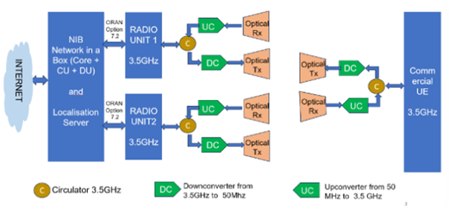
Figure 1 - OWC CFN experimental set-up.

The test bed shown in Figure 1 presents the environmental set-up and equipment used to evaluate the performance of the OWC link and its integration into a 5G Radio Access Network (RAN) within a CFN configuration. It includes a 5G core, a CU and a DU, forming the base of a 5G system in compliance with the requirements of a standard 5G architecture.
In addition, the core components are connected to two RUs (RU1 and RU2), each operating at 3.5 GHz. The integration of these two RUs enables the evaluation of network performance in a cell-free configuration, which is the targeted implementation of the architecture.
Each RU interfaces with the OWC subsystem via circulators (‘C’ in Figure 1). On the transmission path, the circulator is connected to a down-converter (‘DC’ in Figure 1), which conditions the signal from 3.5 GHz to 50 MHz (centre frequency) prior to optical transmission. On the reception path, the circulator is linked to an up-converter (‘UC’ in Figure 1), which restores the signal from 50 MHz back to 3.5 GHz following optical reception. Once signal is in optical domain (baseband signal) the optical transceivers are in charge of the wireless transfer of the signal between the UE and the infrastructure. OWC link acts as a wireless front-haul/mid-haul alternative to RF signal transmission.

On the user equipment (UE) side a standard 5G UE receives the final RF signal after reconversion from optical. A circulator handles duplex communication between Tx and Rx paths and the same DC and UC systems are used in interface with the UE.
This testbed integrates a standard 5G RAN architecture with an optical wireless transmission medium, making it suitable for evaluating how OWC can support or replace traditional fronthaul links. The use of frequency conversion helps align RF signals with the capabilities of optical communication hardware and simplifies the optical link implementation. It presents the minimum number of equipment to validate the performances and KPI of the OWC in CFN configuration.

Localisation test bed architecture
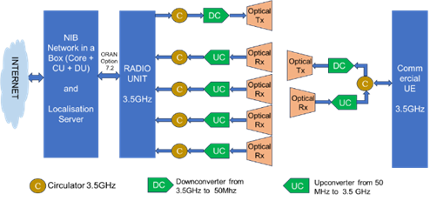
Figure 2 - OWC test setup for localisation.

The test bed shown in Figure 2 presents the environmental set-up and equipment to evaluate the performance of the OWC communication for localisation using various localisation and positioning configurations and methods. Like for the communication set-up in Figure 1, the OWC system is integrated with a 5G RAN. The complete system includes a 5G core, a CU and a DU for the base of 5G system following basic requirements of a standard 5G network. In addition the core bricks are connected to 1 RU as per this configuration no CFN network is required. The radio unit operates at 3.5 GHz.
The RU interfaces with the OWC subsystem via circulators (‘C’ in Figure 2). On the transmission path, the circulator is connected to a DC, which conditions the signal from 3.5 GHz to 50 MHz (centre frequency) prior to optical transmission. On the reception path, the circulator is linked to an UC, which restores the signal from 50 MHz back to 3.5 GHz following optical reception. Once signal is in optical domain (baseband signal) the optical transceivers are in charge of the wireless transfer of the signal between the UE and the infrastructure. OWC link acts as a wireless front-haul/mid-haul alternative to RF signal transmission.

On the UE side, a standard 5G UE receives the final RF signal after reconversion from optical. A circulator handles duplex communication between Tx and Rx paths and the same up and down conversion system are used in interface with the UE.
The UE is identical to the test-bed for communication when on the infrastructure side, a single RU will be used in combination with a single transmitter and 4 receivers. This test-bed setup has been defined in accordance to the requirements of the different localisation method.

Envisioned test bed implementation
The Brunel University 5G/6G Autonomous IoT Lab is subdivided into experimental test and development areas, as shown in Figure 3. The experimental test area is a 5 m x 2.5 m space for performing RSS, TDoA and beamsteering-based positioning experiments. At the two ends of the laboratory, 5G access points are located. For the TDoA localisation and the communication performance tests the 5G RAN will be disconnected from its panel antenna and the four connections redirected to the OWC antennas after suitable up/down conversion as shown in red lines on Figure 3.

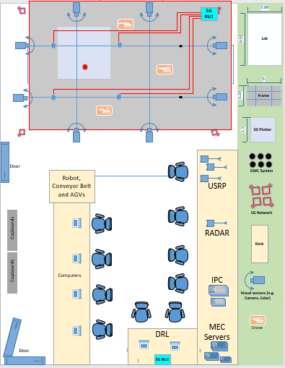 | 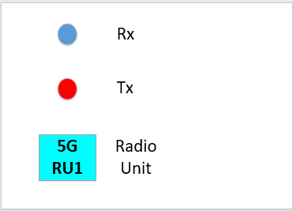
Figure 3 - Physical installation of the OWC TX (Red dot) and RX (Blue dots) antennas for proper TDoA localization and communication performance tests in the Brunel Lab (5 m x 2.5 m).
The experimental test area is reconfigured for performing cell-free performance test experiments. At the two ends of the laboratory, 5G access points are located. For the cell-free communications performance tests, the two 5G RANs will be disconnected from their panel antenna and two connections from each of the 5G RANs redirected to the OWC antennas in the experimental test area to create two access areas, as shown in red lines on Figure 4.
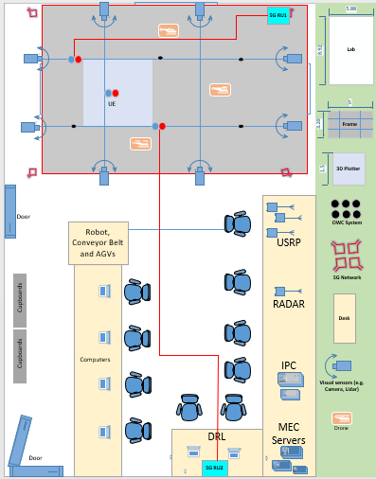

Figure 4 - Physical installation of the OWC TX and RX antennas (UE in the middle) for proper cell free performance tests in the Brunel Lab (5 m x 2.5 m).

TDoA localisation test setup
The TDoA based UE localisation system consist of a standard commercial 5G private end to end network (See Figure 2 above) that includes a Server with the 5G Private Core, the CU and the DU connected via the O-RAN interface (option 7.2) to a RU with four TX/RX channels that have been modified to work in the optical domain (up to 1050 nm) instead of the sub-6GHz (3.3 to 3.8 GHz).
The Private 5G Network is connected to an UE that also was modified to communicate with the 5G Network in the optical band (1050 nm) as explained in deliverable D3.1 [OPT24b]. The main design challenges in regard to the UE location measurement research is in the O-RAN Interface between the RU and the DU due to the fact that the dedicated ToA measurement module within the RU needs information from the DU on the allocation of some specific data stream coming from the UE on the uplink, as described in the following paragraphs:
• Positioning detection in the RU, is based on distance measurements from UE transmit antenna to each RU receive antenna.
• Distance measurements are derived from knowledge of the channel state of each antenna.
• Accuracy of the location estimation depends on the location of the RU receive antennas.
• Therefore, channel state must be calculated for each UE whose location is required.
• The RU ToA measurement processor needs to have the exact allocations to the user and from the user in real time.
• The RU calculates the ToA based on the channel state and the following parameters in the UL: UE RNTI (16 bit); Type (4 bit); DMRS, SRS, etc.; Type parameters (about 6 bit); Symbol (4 bit); First RB (9 bit); Number of RB (9 bit); Number of OFDM symbols (pilots + data).
The parameters above are known at the scheduler in the DU MAC layer and are needed in the RU at the same timing as the uplink C-plane.
The technology used to achieve the outstanding TDoA measurement accuracy is based on a special Phase processing of the plurality of the OFDMA received signal subcarriers. The signal is transmitted by UE and received by several Radio Units or a distributed antennae array connected to the same RU.
The novel patented RunEL algorithm enables TDoA measurement accuracy of around 30 picoseconds which is equivalent to 1 cm in range accuracy. The TDoA is measured by several RUs (or antennas connected to the same RU) deployed in the coverage area, the mechanism is calibrated using pre-known elements position. Measurements results are delivered to the Edge Cloud Positioning Server for calculating the target UE position using hyperbolic trilateration techniques.
To enhance the measurements accuracy, a reference UE, which location is pre-known, is used for calibration of the measurements. This technique enables fast update (every 0.5 millisecond) of the location of multiple standard commercial 5G UEs of various types and sizes in the 5G coverage areas.

RSS localisation test setup
To achieve localisation, the Received Signal Strength (RSS) in the uplink must be measured. The objective is to transmit a signal from the terminal and capture it at multiple spatially distributed antennas. Therefore, system design and strategic placement of antennas (nodes) within the environment are essential to enhance the localisation process and improve accuracy [1, 2]. Furthermore, a system that supports signal measurement is vital for conducting experiments and evaluating performance.
Modifying System and Developing Measurement Procedures
The current system used in the lab (LiFiMAX by Oledcomm) is a commercial product developed for general consumer and industrial applications [OLE24]. However, it lacks built-in capabilities for signal measurement. As a result, both software and hardware modifications are required to extract the uplink signal and measure the RSS at each antenna, as illustrated in Figure 5.
Automatic Gain Control (AGC) is a key feature in many electronic systems. It automatically adjusts signal amplification to maintain a consistent output level despite variations in input signal strength. Commonly used in audio equipment, radio receivers, and communication systems, AGC helps ensure signal clarity by attenuating overly strong signals and boosting weak ones for better audibility. While AGC enhances performance in fluctuating signal environments, it can pose a challenge in localisation applications. By adjusting the received signal strength, AGC masks the natural attenuation caused by distance, complicating efforts to estimate the transmitter’s location.

Software Modifications: AGC has been disabled to eliminate AGC compensation effects, ensuring accurate uplink RSS detection.

Hardware Modifications: A custom circuit is designed to:
- Access relevant signal data,
- Convert the signal from differential to single-ended,
- Identify and measure the uplink received signal.

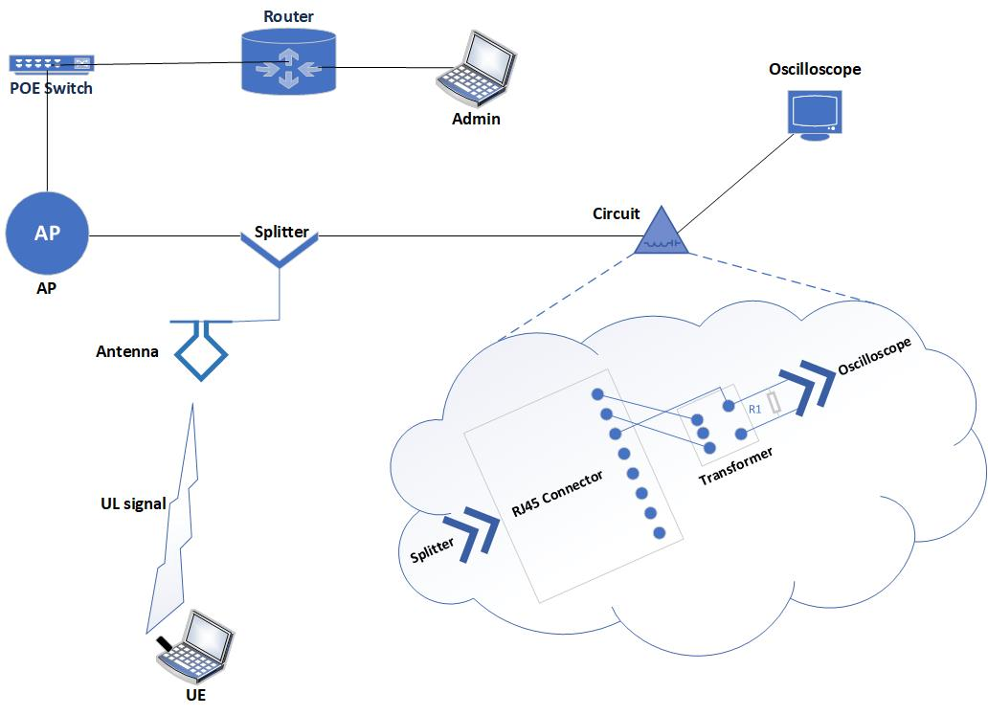
Figure 5 - Proposed Modification.

Circuit Design
Optical antennas, illustrated in Figure 6 [3], are connected to the access point (AP) via an Ethernet cable to convey TX and RX signals as well as DC power from the AP to the antenna.
The objective of this section is to design a circuit that:
- Extracts the relevant data from the differential signal.
- Converts it into a single-ended signal (also referred to as a singular signal).

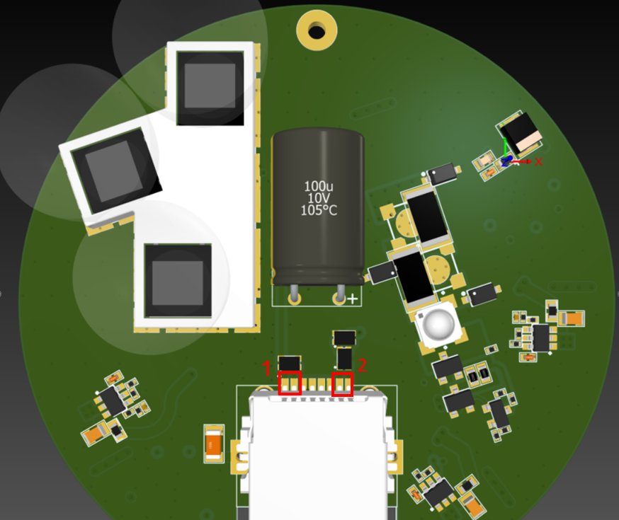
Figure 6 - Optical Antenna [3].
An RJ45 2-way splitter is introduced into the system, as depicted in Figure 7. This splitter divides a single Ethernet connection into two separate paths, allowing both the AP and the circuit to share the same antenna data connection.

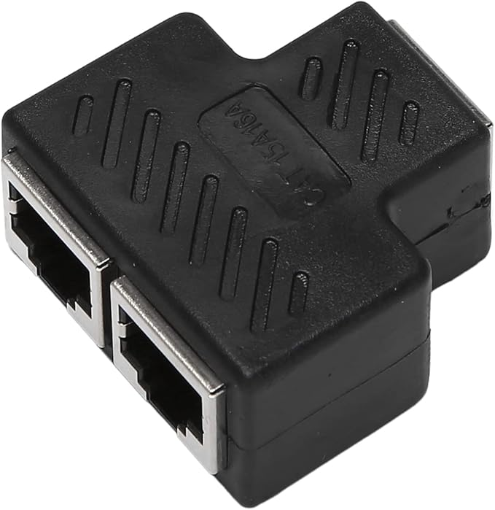
Figure 7 - RJ45 2-Way Splitter.

To access different pins on the antenna and enable wired communication between system components, an RJ45 connector is installed, as illustrated in Figure 8.
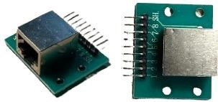
Figure 8 - RJ45 Connector.

Several common methods exist for converting a differential signal to a single-ended signal, each suited to different applications. One widely used passive approach employs a transformer (e.g., an RF balun), which converts the differential pair into a single-ended output via magnetic coupling. This method is simple, power-free, and effective for high-frequency signals.
In this work, we adopt the passive approach due to its simplicity, low noise, and lack of power requirements. Specifically, we use the MABAES0060 RF 1:1 Flux Coupled Transformer (Figure 5), designed by MACOM for operation across 0.3–200 MHz [4]. This transformer is RoHS-compliant and optimized for cellular/wireless applications, particularly where differential-to-single-ended conversion is required. An application schematic is provided in Figure 10.
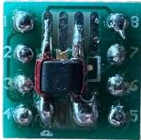
Figure 9 - MABAES0060 RF 1 :1 Flux Coupled Transformer.

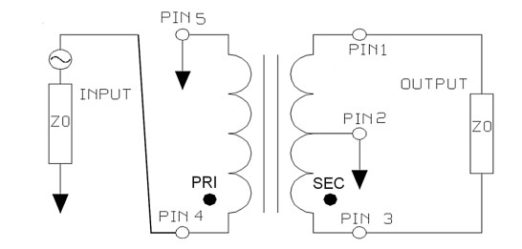

Figure 10 - Application Schematic [4].

Short jumpers are used to connect the transformer to the antenna through the RJ45 splitter and connector. As specified in Figure 2, Pin 1 and Pin 2 of the Ethernet cable (the first differential pair on the antenna) must be connected to Pin 1 and Pin 3 of the transformer, respectively, following the pin configuration shown in Figure 11.

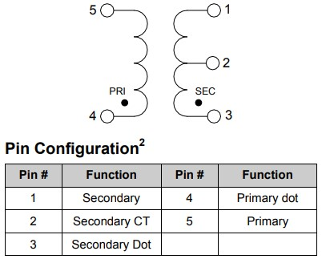
Figure 11 - Functional Schematic with Pin Configuration [4].

At this stage, a breadboard is used as a temporary platform for prototyping and circuit evaluation. As shown in Figure 12, both the transformer and RJ45 connector are integrated into the breadboard for testing purposes.
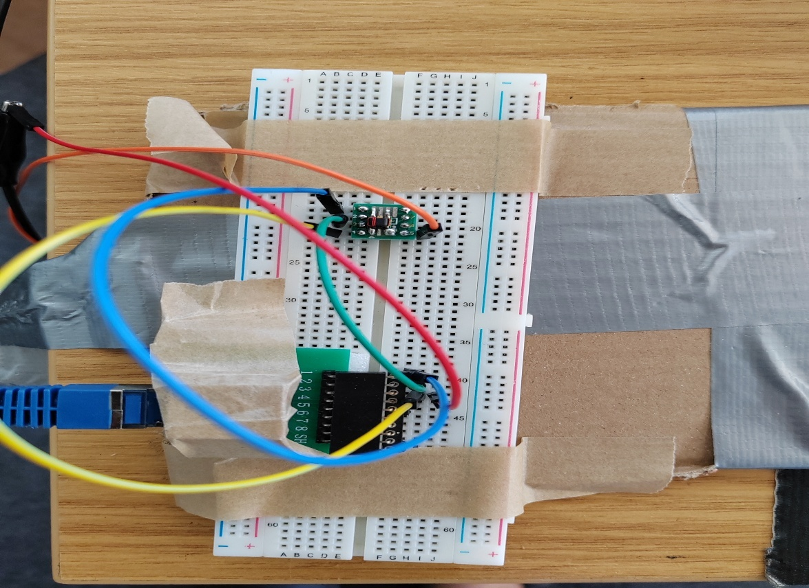
Figure 12 – Breadboard

Signal Identification and Preliminary Results
The transformer solution must be implemented in both differential pairs, for uplink and downlink pulses, respecting the same scheme, whereas the output is on pin 5. To properly analyze these signals, the study was divided into two phases for RSS (Received Signal Strength) identification and measurement.

Phase 1: Downlink Signal Identification
The downlink signal was captured at the second differential pair of the antenna. The results (shown in Figures 13, 14 and 15) confirm successful downlink signal reception.
Further analysis via FFT (Fast Fourier Transform) in Figures 10 and 11 reveals the signal bandwidth to be approximately 46 MHz, validating the expected frequency characteristics.
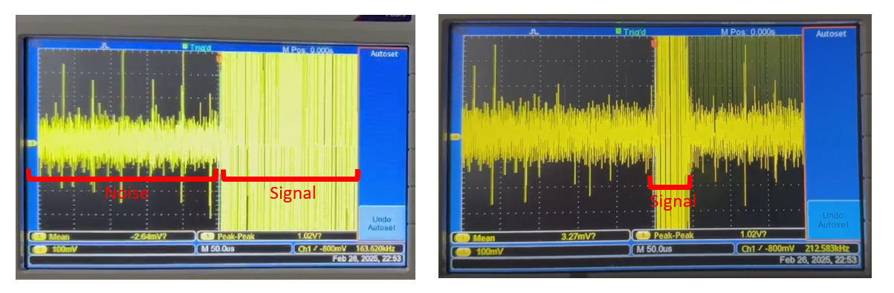
Figure 13 - Downlink Signal – Time Domain.

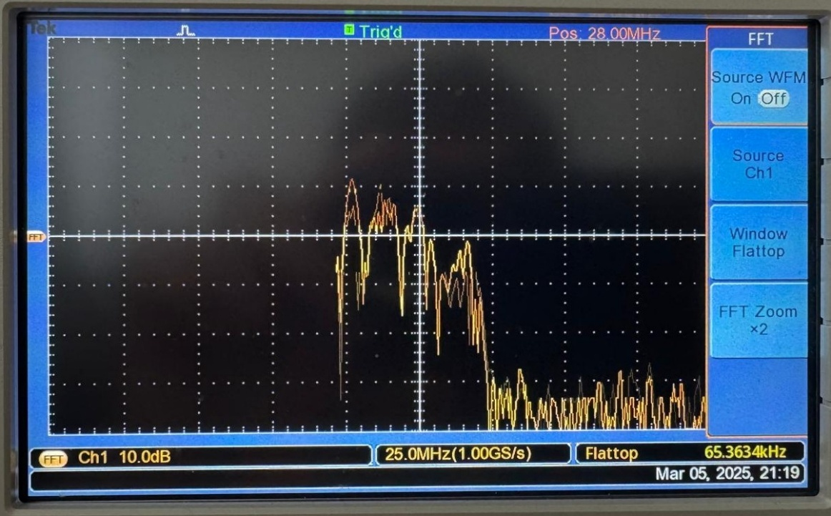

Figure 14 - Downlink Signal – FFT.

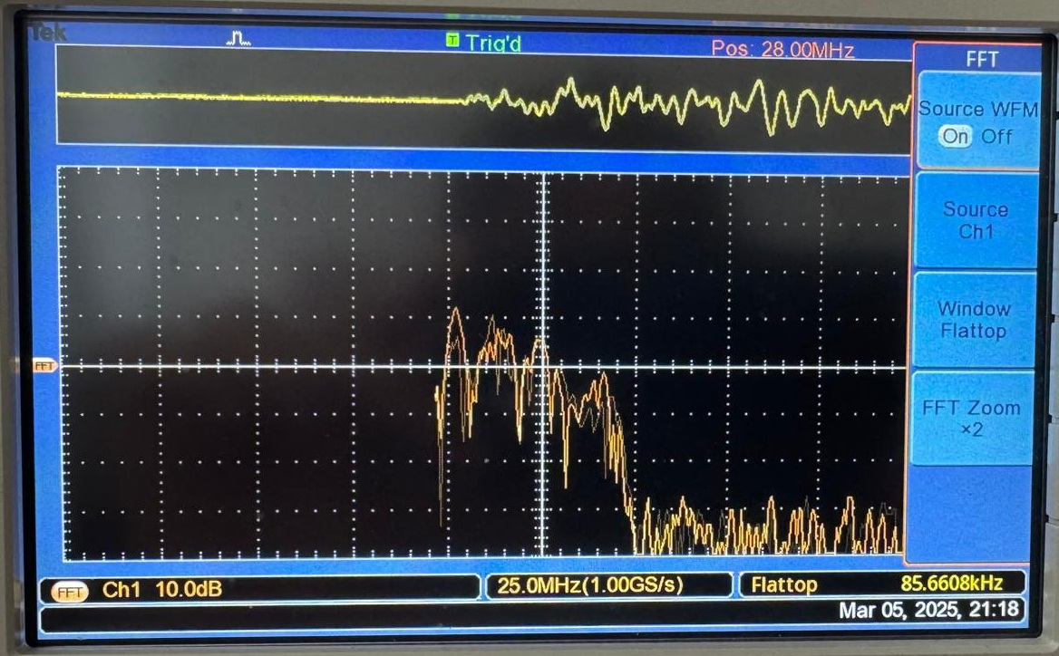

Figure 15 - Downlink Signal – FTT.

Phase 2: Uplink Signal Analysis
In this phase, the signal was captured at the first differential pair of the antenna (Pins 1 and 2) using the custom circuit shown in Figure 5. Several scenarios were evaluated to identify and measure the RSS in the UL.

Measurement Setup
- Location 1: ~2 metres from the antenna
- Location 2: ~1.4 metres from the antenna

Key Observations
Uplink Signal: The uplink signal amplitude increased from ~70 mV to ~100 mV as the UE moved closer to the antenna. This aligns with theoretical expectations, as reduced path loss at shorter distances typically results in stronger signal reception.

Downlink Echo: The downlink signal remained stable at ~300 mV peak-to-peak across both positions, showing no significant variation with distance. This consistency is consistent with the findings of Oledcomm, as illustrated in Figure 16.

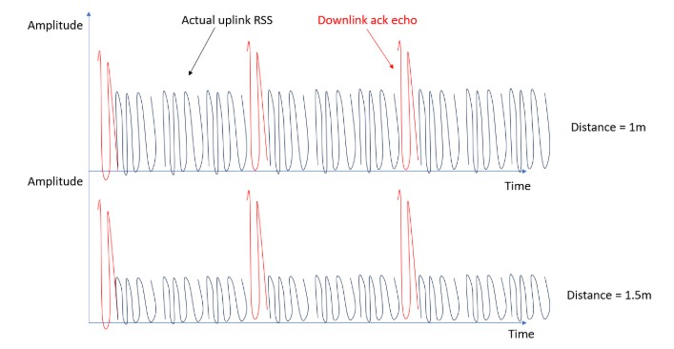
Figure 16 - Expected Signal.

Scenario 1: Baseline Measurement (No UE Connected)
When no User Equipment (UE) is connected to the system, Figure 17 demonstrates that only the downlink pulses are captured. The observed downlink echo signal maintains a consistent amplitude of approximately 300 mV, confirming two key characteristics:
- The downlink signal is successfully detected by the system.
- The signal strength remains unaffected by distance variations (as established in Phase 2) nor UE connection status.
These results validate the expected behavior of the downlink signal as a persistent system component, independent of UE presence.
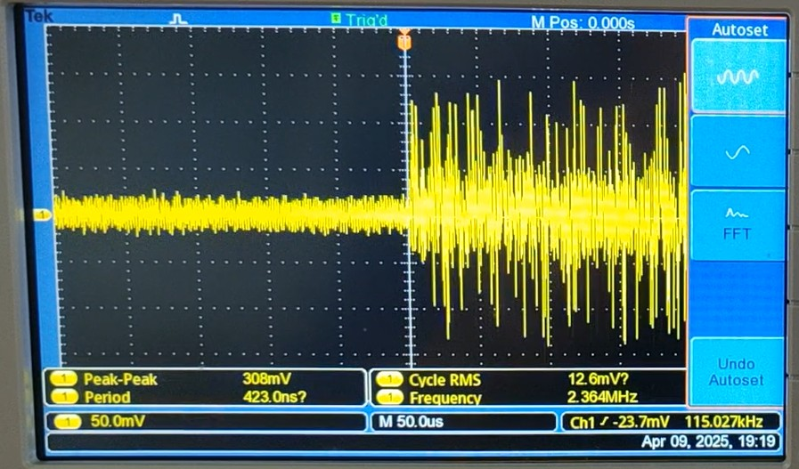
Figure 17 - No UE connected to System.

Scenario 2: Uplink Traffic Analysis (UE at 2m Distance)
Test Configuration
- UE Connection: The UE is connected to the system and positioned 2 metres from the antenna.
- Uplink traffic is actively transmitted from the UE to the admin machine via the LiFi system (refer to Figure 5).
- Traffic Generation: The following iperf3 commands were executed to generate and measure uplink traffic:

    - UE Machine (Figure 18):
iperf3 -s

    - Admin Machine (Figure 19):
Iperf3 -c "IP address of UE machine"
Results
- Uplink Signal: ~66 mV (measured at the antenna’s first pair, Pins 1–2).
- Downlink Echo: ~298 mV (consistent with baseline observations).
- Data corroborated by Figures 20 and 21.
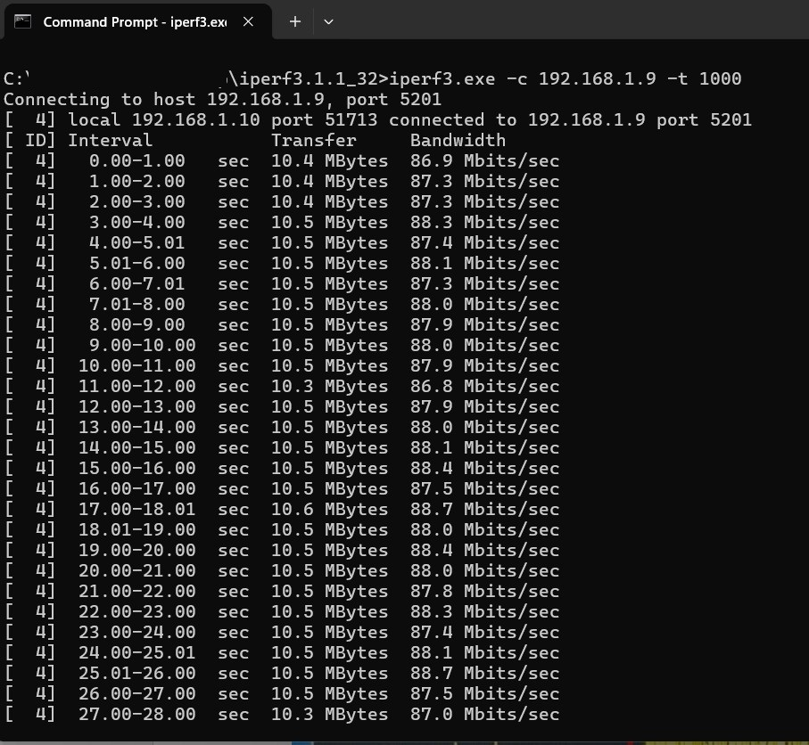
Figure 18 - iperf3 command on UE machine

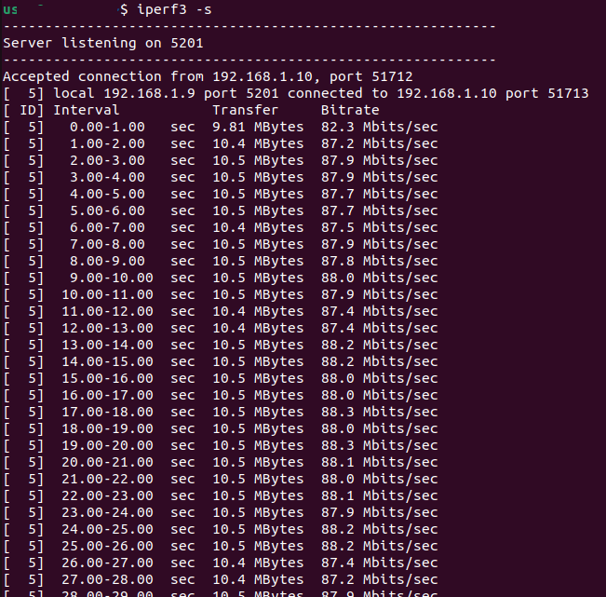
Figure 19 - iperf3 command on Admin Machine
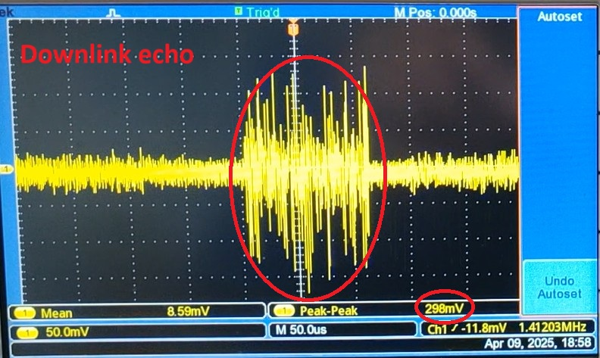
Figure 20 - Downlink Echo Signal - Location 1.

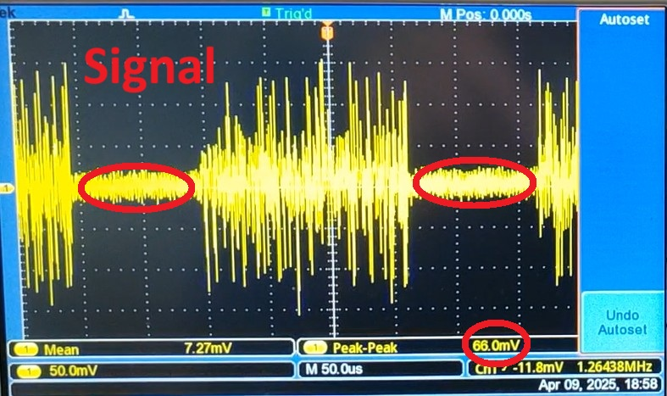
Figure 21 - Uplink signal - Location 1.

Scenario 3: Uplink Traffic Analysis (UE at 1.4m Distance)
Test Configuration
- UE Connection and Positioning: The User Equipment (UE) is connected to the system and positioned at a distance of 1.4 metres from the antenna.

- Traffic Generation: Uplink traffic is actively transmitted from the UE to the admin machine via the LiFi system (refer to Figure 5). The following iperf3 commands were executed to generate and measure uplink traffic:

    - UE Machine (Figure 18):
iperf3 -s

    - Admin Machine (Figure 19):
Iperf3 -c "IP address of UE machine"

Measurement Results
- Uplink Signal Strength: ~100 mV
- Downlink Echo Signal: ~302 mV
- Signal characteristics confirmed by Figures 22 and 23

Key Observations:
- The uplink signal shows a 33% increase (from ~66 mV to ~100 mV) compared to the 2m distance scenario.
- The downlink echo remains stable with only 1.3% variation (from ~298 mV to ~302 mV).
- Results demonstrate the expected inverse relationship between signal strength and distance.
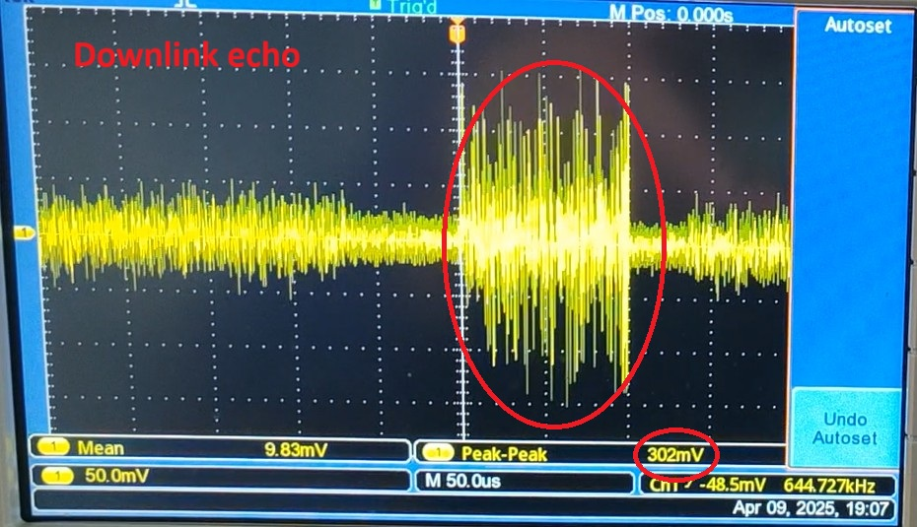
Figure 22 - Downlink echo signal - Location 2.

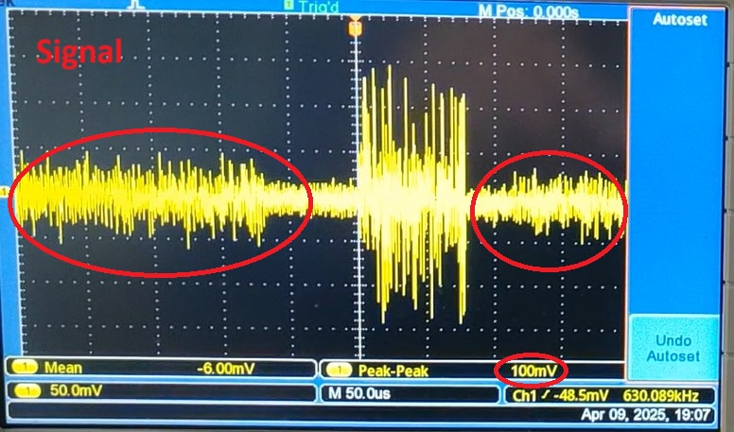
Figure 23 - Uplink Signal – Location 2.

Beamsteering-based localisation test setup
The beamsteering-based localisation test setup that will eventually be implemented within Brunel’s 5G/6G Autonomous IoT Lab is an evolution of that previously described in D4.1 (Section 5.4) [OPT24c], and shown in Figure 6.

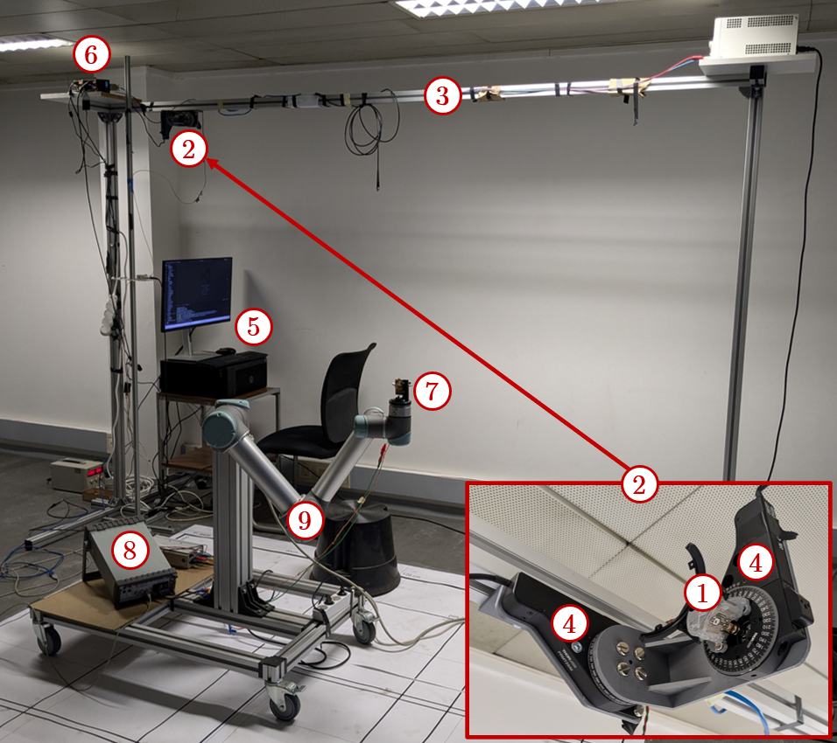
Figure 24 – First version of the beamsteering-based positioning test bench
This test bench relies on the infrastructure side on the RU’s optical antenna (especially its Tx) ① operating so as to enable both cell-free communication and positioning, as previously described. Note that the component ① in Figure 6 is a simple LED, shown to illustrate the overall implementation of the test-bed, but this will be replaced by an actual RU’s optical antenna in the final demonstrator. Note also that in practice, the type of signal sent by this optical antenna does not matter, as only its continuous part is exploited by the proposed beamsteering-based positioning method, as explained in D4.1 (Section 5.2).
This optical antenna is installed on a homemade mechanical stage ②, itself fixed to a bracket ③ at given height.This stage is designed to control the orientation of the antenna’s optical axis with two rotational degrees of freedom. It consists of two orthogonal Thorlabs PRMTZ8/M motorized precision rotation stages ④, controlled themselves by the localisation server ⑤ (here a computer for illustration) via Thorlabs KDC101 servo motor controllers ⑥. As shown in Figure 7, the mechanical parts of this rotational stage have been upgraded. In particular, a platform has been added to enable fixing optical antennas with variable form factors at the center of rotation of the stage while avoiding physical obstructions of the optical signal when changing the orientation. Depending on the optical antenna used, a specific support can be designed and then screwed to this platform (see the four holes in the platform highlighted by the red circle in Figure 7). At the same time, a perpendicular support may be added (see green circle in Figure 7) to install monitoring electronic boards, e.g. an additional photodiode with dedicated circuitry to monitor the optical power output.
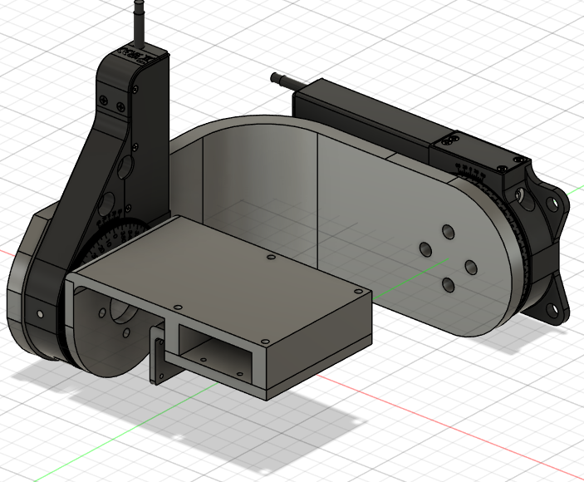
Figure 25 – Gimbal-based beamsteering stage designed to support multiple RU’s optical antenna form factors while keeping their optical transmitter at the center of rotation.
On the other end of the link, the UE’s optical antenna ⑦ (here a custom-made optical receiver) is attached to the gripper of a Universal Robots URS robot arm ⑨, which position and orientation can be controlled by a test computer ⑤ (here the same computer as that used the control the orientation of the RU’s optical antenna, but which will be separate from the localisation server in the final demonstrator). The UE’s optical antenna will be directly used to capture the RSS of the signals received from the different orientations of the RU’s optical antenna and then compute the UE’s localisation, using the process described in D4.1 (Section 5.3). Once estimated, the UE’s position will be sent by the UE itself to the RU and therefore to the localisation server via the RU-UE OWC link. However, if necessary, an additional external voltmeter ⑧ can be connected to the UE’s optical antenna to get another RSS measure and then compute the UE’s localisation from an external device, such as the computer ⑤. In practice, this test bench offers great flexibility, as demonstrated by extensive experiments already carried out at UVSQ with both custom-made optical antennas and commercial antennas from OLED. In particular, the use of the robotic arm allows to test several actual positions of the UE automatically (with routines already developed) and quickly with great precision, over an area of around 2 m², without having to change the position of the center of the robotic arm. The test area can then be extended by simply changing this position manually. In addition, a second mechanical stage can easily be 3D-printed and assembled to be then added to the bracket if a second RU’s optical antenna is needed for test purpose (e.g. 3D positioning with the 2-transmitter method detailed in D4.1, Section 5.2.4).

KPI definition
KPIs that are planned to be measured in the laboratory experiments are for:
- Communication performance and link availability.
- TDoA localisation accuracy, coverage, latency and ISAC compatibility.
- RSS localisation accuracy, coverage, latency and ISAC compatibility
- Beamsteering-based localisation accuracy, coverage, latency and ISAC compatibility.
- CFN handover packet loss.

KPIs for OWC communication
In order to properly characterize the performance of the OWC CFN, two types of KPIs will be collected, one to evaluate the raw performance of the communication system, and the other to assess link availability within the coverage area.
For the communication performances following KPIs will be measured:
- Throughput
Targeted Value: 150 Mbps on MAC layer (200 Mbps on PHY layer)
KPI definition: Measurement of downlink and uplink data rates on the user equipment side. PHY and MAC layer performance will be retrieved.
- Latency
Targeted Value: ≤ 10 msec
KPI definition: End-to-end delay, including signal conversion and OWC link delays. To evaluate the latency the value to be taken into account is the RTT (Round-Trip Time) which is the total time it takes for a signal to travel from a source to a destination and back again.
- Jitter
Targeted Value: ≤ 50msec
KPI definition: Variability in packet delay, critical for real-time applications. It is a representation of the stability of the latency across the time.
- Bit Error Rate (BER) / Signal-to-Noise Ratio
Targeted Value: > 10⁻⁶
KPI definition: Quality of signal transmission over the optical wireless channel.
For the link availability evaluation following KPIs will be measured:
- Coverage Area
Targeted Value: 5 m² at 2 m distance
KPI definition: Effective range and spatial coverage of the OWC-enabled RUs.
- Link Availability
Targeted Value: 99%
KPI definition: Percentage of time the OWC links are operational without degradation.
- Handover Performance
Targeted Value:
Latency ≤ 100 ms
Packet loss ≤ 0.1%
Throughput drop ≤ 10%
KPI definition: Smoothness and reliability of user handover between RUs in CFN defined by connection and/or packet losses whilst transitioning access area coverage boundaries. Main metrics to be retrieved in order to establish the performances of the CFN for stable and seamless user experience are the handover interruption time (latency), the throughput drop from the baseline and the packet losses during handover phase. Values should be kept in a range where the quality of service (QOS) is not affected. Standard values of 3GPP have been taken into account in order to establish the compliance of the OWC CFN system.

KPIs for localisation

TDoA localisation KPIs
- Localisation accuracy:
  - Target value: < 5 cm.
  - KPI definition: $ε_{90\%}$ the root mean square (RMS) error threshold under which 90% of the errors on all the 2D/3D test points considered are.
- Coverage:
  - Target value: 2m x 2m x 2m.
  - KPI definition: The coverage is defined as the volume in which the UE can be located with accuracy as defined above.
- Extra-latency:
  - Target value: < 10 msec.
  - KPI definition: Extra-latency is defined as the time needed to orientate the APs in all the necessary directions and then estimate the UE’s localisation, including with the ML layers. However, this latency does not include the transmission latency from the UE to the AP, for further processing by the localisation server, which is why it can be seen as the extra-latency added by the proposed OWP technique compared to the case it is not used.
- ISAC-compatibility:
  - Target value: Yes.
  - KPI definition: The proposed TDoA based UE location measurement technique should not degrade the communication performance of the OPTI-6G system (see D3.1 for more details about this communication function).

RSS localisation KPIs
The proposed RSS-based OWP technique is eventually expected to meet the following KPIs:
- Localisation accuracy:
  - Target value: < 5 cm.
  - KPI definition: $ε_{90\%}$ the root mean square (RMS) error threshold under which 90% of the RMS errors on all the 2D/3D test points considered are.
- Coverage:
  - Target value: 1.6m x 1.6m at 1.8 m distance.
  - KPI definition: The coverage is defined as the volume in which the UE can be located with accuracy as defined above.
- Extra-latency:
  - Target value: < 10 ms.
  - KPI definition: Extra-latency is defined as the time needed to orientate the APs in all the necessary directions and then estimate the UE’s localisation, including with the ML layers. However, this latency does not include the transmission latency from the UE to the AP, for further processing by the localisation server, which is why it can be seen as the extra-latency added by the proposed OWP technique compared to the case it is not used.
- ISAC-compatibility:
  - Target value: Yes.
  - KPI definition: The proposed beamsteering-based OWP technique should not substantially degrade the communication performance of the OPTI-6G system (see D3.1 for more details about this communication function).

Beam-steered based localisation KPIs
The proposed beam-steering-based OWP technique is eventually expected to meet the following KPIs:
- Localisation accuracy:
  - Target value: $ε_{90\%}<$ 5 cm
  - KPI definition: $ε_{90\%}$ the root mean square (RMS) error threshold under which 90% of the RMS errors on all the 2D/3D test points considered are.
- Coverage:
  - Target value: 2x2x2 m³ with a single AP.
  - KPI definition: The coverage is defined as the volume in which the UE can be located with accuracy as defined above.
- Extra-latency:
  - Target value: 20 ms.
  - KPI definition: Extra-latency is defined as the time needed to estimate the UE’s localisation, including ML layers, once the RU’s optical antenna has been oriented in at least three different directions and the corresponding RSS have been acquired. This latency does not include the time needed to successively orientate the optical antenna, as the development of a fast beamsteering solution is not the primary focus of the project. In addition, this latency does not include the transmission latency from the UE to the RU, for further processing by the localisation server.
- ISAC-compatibility:
  - Target value: Yes.
  - KPI definition: The proposed beam-steering-based OWP technique should not substantially degrade the communication performance of the OPTI-6G system (see D3.1 for more details about this communication function).

Test procedures

Test procedures for cell free network KPIs testing

[TP1] Throughput of OWC
Purpose: Measurement of downlink and uplink data rates on the user equipment side.
Experimental set-up: Communication set-up (see Figure 1)
Test procedure:
1- Connect a client machine to the UE
2- Connect a server machine to the NIB
Both machines should run Iperf3
3- Configure both machine’s interface on the same subnetwork range (ex: 192.168.1.10 and 192.168.1.12)
4- Launch iperf3 on server machine with the following command: iperf3 -s
5- Lauch iperf3 on client machine with the following command (for 60s test in downlink) : iperf3 -c “serverIP” -t 60
6- Retrieve mean value of downlink in the test result
7- Lauch iperf3 on client machine with the following command (for 60s test in uplink) : iperf3 -c “serverIP” -t 60 -R
8- Retrieve mean value of uplink in the test result
Expected result: Throughput in uplink and downlink should be greater than 150Mbps
————————————
[TP2] Latency of OWC
Purpose: Measurement of latency (RTT) in the OWC system
Experimental set-up: Communication set-up (see Figure 1)
Test procedure:
1- Connect a client machine to the UE
2- Connect a server machine to the NIB
Both machines should run Iperf3
3- Configure both machine’s interface on the same subnetwork range (ex: 192.168.1.10 and 192.168.1.12)
4- Launch iperf3 on server machine with the following command: iperf3 -s
5- Lauch iperf3 on client machine with the following command (for 60s test in downlink) : iperf3 -c “serverIP” -t 60
6- Retrieve latency mean value
Expected result: Mean latency should not be greater than 10ms
————————————
[TP3] Jitter of OWC
Purpose: Measurement of the jitter in the OWC system
Experimental set-up: Communication set-up (see Figure 1)
Test procedure:
1- Connect a client machine to the UE
2- Connect a server machine to the NIB
Both machines should run Iperf3
3- Configure both machine’s interface on the same subnetwork range (ex: 192.168.1.10 and 192.168.1.12)
4- Launch iperf3 on server machine with the following command: iperf3 -s
5- Lauch iperf3 on client machine with the following command (for 60s test in downlink) : iperf3 -c “serverIP” -t 60
6- Retrieve jitter value
Expected result: Jitter should not be greater than 50ms
————————————
[TP4] BER of OWC
Purpose: Measurement of the BER in the OWC system
Experimental set-up: Communication set-up (see Figure 1)
Test procedure:
1- Connect a client machine to the UE
2- Connect a server machine to the NIB
Both machines should run Iperf3
3- Configure both machine’s interface on the same subnetwork range (ex: 192.168.1.10 and 192.168.1.12)
4- Launch iperf3 on server machine with the following command: iperf3 -s
5- Lauch iperf3 on client machine with the following command (for 60s test in downlink) : iperf3 -c “serverIP” -t 60
6- Retrieve the number of packet lost. Default packet size is 128KB
7- Calculate BER based on:
- size of the packets
- number of packets lost
- quantity of data transfered
Expected result: BER should not be lower than 10⁻⁶

————————————
[TP5] Coverage of OWC
Purpose: Measurement of the BER in the OWC system
Experimental set-up: Communication set-up (see Figure 1)
Test procedure:
1- Connect a client machine to the UE
2- Connect a server machine to the NIB
3- Configure both machine’s interface on the same subnetwork range (ex: 192.168.1.10 and 192.168.1.12)
4- Starting from the middle of the test area (2.5x5m), send a ping command from the client: ping IPserver
5- Move around the testing area and check place where you can still ping the server. 4 position of disconnection should be detected at (+X, -X, +Y, -Y) with respect to the centre of the testing area.
6- Measure the relative distance with respect to the centre for each position
7- Calculate the coverage area in sqm
Expected result: Coverage area should be at least 5sqm for a distance of communication of 2m
————————————
[TP6] Link availability of OWC
Purpose: Measurement of link availability in the OWC system
Experimental set-up: Communication set-up (see Figure 1)
1- Connect a client machine to the UE
2- Connect a server machine to the NIB
Both machines should run Iperf3
3- Configure both machine’s interface on the same subnetwork range (ex: 192.168.1.10 and 192.168.1.12)
4- Launch iperf3 on server machine with the following command: iperf3 -s
5- Lauch iperf3 on client machine with the following command (for 60s test in downlink) : iperf3 -c “serverIP” -t 3600
6- At the end of the test check if a data is available for each second of the test in the registry
Expected result: Availability should be at least 99% meaning that the connection should have been up and running for at least 3564s.

————————————

[TP7] Handover performance of OWC
Purpose: Measure the data link stability in handover area between the cell in the OWC system
Experimental set-up: Communication set-up (see Figure 1)
Test procedure:
1- Connect a client machine to the UE
2- Connect a server machine to the NIB
3- Configure both machine’s interface on the same subnetwork range (ex: 192.168.1.10 and 192.168.1.12)
4- Launch iperf3 on server machine with the following command: iperf3 -s
5- Lauch iperf3 on client machine with the following command (for 60s test in downlink) : iperf3 -c “serverIP” -t 3600
5- Move around the testing area to switch from one Cell to the other.
6- Check the quantity of connection and/or packet losses whilst transitioning access area coverage boundaries.
7- Check throughput drop whilst transitioning access area coverage boundaries.
8- Check latency variation whilst transitioning access area coverage boundaries.
Expected result:
Latency should be lower or equal to 100ms
Packet loss should be lower or equal to 0.1%
Throughput drop should be lower or equal to 10%
whilst transitioning from one cell to another
————————————

Test procedures for localisation KPIs testing

TDoA localisation test procedure
The detailed test plans that will be put in place to validate the proposed ToA-based OWP technique will be detailed in Deliverable D4.3, but a general outline of these plans are outlined in Chapter 3 of deliverable D6.4 of the 6G Brains project [COS23] where a similar test was performed at 3.5GHz spectrum while in the Opti 6G case it will be done in the optical domain.

[TP8] Performances of TDoA localisation
Purpose: These validation tests broadly consist in validating the accuracy, latency and positioning coverage of TDOA localisation method.
Experimental set-up: Localisation set-up (see Figure 2)
Test procedure:
1- The UE is successively positioned at different locations, the coordinates of which are known (using external sensors, such as a laser rangefinder, and/or from the reference of the double axis plotter, which is programmable).
2- At each location, a position measurement process is performed, to obtain an estimate of the UE coordinates.
3- These estimates are compared with the actual coordinates to obtain the RMS error.
4- At the same time, a timer is triggered to determine the latency of the positioning measurement.
5- The empirical CDF of all these RMS errors is then evaluated, to determine the accuracy metric $ε_{90\%}$, defined in Section 3.4. An average latency can also be derived from the latency measurements made for each location.

Expected result:
Localisation accuracy ($ε_{90\%})$should be lower than 5 cm.
Total surface of the localisation area should be at least 4 sqm with a single AP (2x2m).
Extra-latency added by the OWC localisation system should lower or equal to 10 ms.

RSS localisation test procedure
The detailed test plans that will be put in place to validate the proposed RSS-based OWP technique will be detailed in Deliverable D4.3, but a general outline of these plans can already be proposed, based on initial validation tests that have been carried out using the test bench described in Section 4.3 (see [SHI24] for more details).

[TP9] Performances of RSS localisation
Purpose: These validation tests broadly consist in validating the accuracy, latency and positioning coverage of RSS localisation method.
Experimental set-up: Localisation set-up (see Figure 2)
Test procedure:
1- The UE is successively positioned at different locations, the coordinates of which are known (using external sensors, such as a laser rangefinder, and/or from the reference of the double axis plotter, which is programmable).
2- At each location, a position estimation process is then performed, to obtain an estimate of the UE coordinates.
3- This estimate is compared with the actual coordinates to obtain an RMS error.
4- At the same time, a timer is triggered to determine the latency of the positioning measurement.
5- The empirical CDF of all these RMS errors is then evaluated, to determine the accuracy metric $ε_{90\%}$, defined in Section 4.4. An average latency can also be defined from the latency measurements made for each location.
6- It should be noted that some of the locations tested can later be used as training data for the ML methods tested.

Expected result:
Localisation accuracy ($ε_{90\%})$should be lower than 5 cm.
Total surface of the localisation area should be at least 2.56 sqm with a single AP (1.6m x 1.6m).
Extra-latency added by the OWC localisation system should lower or equal to 10 ms.

Figure 26 shows an example of a 2D positioning test result obtained during an initial validation campaign of the RSS-based OWP technique without ML but with a deterministic correction method. These results are represented in Figure 26(a) as a top view of the $u_{x}$-$u_{y}$ reception plane in which the UE can move. Its actual positions are shown in blue, while estimated positions are shown in red (before correction) and in black (after correction), and linked to the actual positions to which they correspond by a dotted line. They can also be represented as in Figure 26 (b), as an empirical CDF, which enables to determine the $ε_{90\%}$ metrics, reaching in this example 5.9 cm after correction (yellow curve).
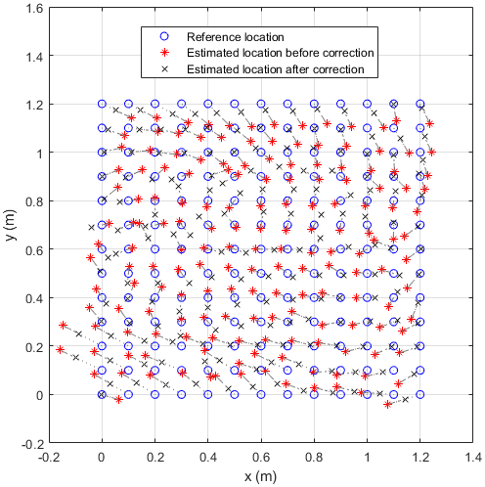 | 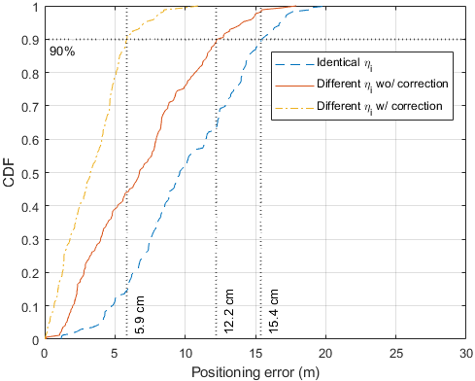
(a) | (b)
Figure 26 - Example of expected test results (2D positioning case)

Beam-steered based localisation test procedure
The detailed test plans that will be put in place to validate the proposed beam-steering-based OWP technique will be detailed in Deliverable D4.3, but a general outline of these plans (essentially similar to that drafted in D4.1) can already be proposed, based on the initial validation tests that have been carried out using the test bench described in Section 1.3.3.

[TP10] Performances of Beam-steered based localisation
Purpose: These validation tests broadly consist in validating the accuracy, latency and positioning coverage of beamsteering-based localisation method.
Experimental set-up: Localisation set-up (see Figure 2).
Test procedure:
1- The UE is successively positioned at different locations, the coordinates of which are known (using external sensors, such as a laser rangefinder, and/or from the reference of the robotic arm and the coordinates of its gripper, which are programmable).
2- At each location, a position estimation process is then performed, to obtain an estimate of the UE coordinates.
3- This estimate is compared with the actual coordinates to obtain an RMS error.
4- At the same time, a timer is triggered to determine the latency of the positioning measurement.
5- The empirical CDF of all these RMS errors is then evaluated, to determine the accuracy metric $ε_{90\%}$, defined in Section 2.2.3. An average latency can also be defined from the latency measurements made for each location.
6- It should be noted that some of the locations tested can later be used as training data for the ML methods tested.

Expected result:
Localisation accuracy ($ε_{90\%})$should be lower than 5 cm.
Total surface of the localisation area should be at least 4 m² with a single RU’s optical antenna.
Extra-latency added by the OWC localisation system should lower or equal to 20 ms.

Figure 27 shows an example of a 2D positioning test result obtained during an initial validation campaign for the proposed method. These results are represented as a top view of the $x$-$y$ reception plane in which the UE can move. Its actual positions are shown in blue, while estimated positions are shown in red, and linked to the actual positions to which they correspond by a dotted line. Note that some test points are not shown, as they were used as training data for the ML method used. Ultimately, the accuracy metric in this case is $ε_{90\%}$ = 2.8 cm, while the average latency is of the order of ten ms (no systematic evaluation during this first test campaign).
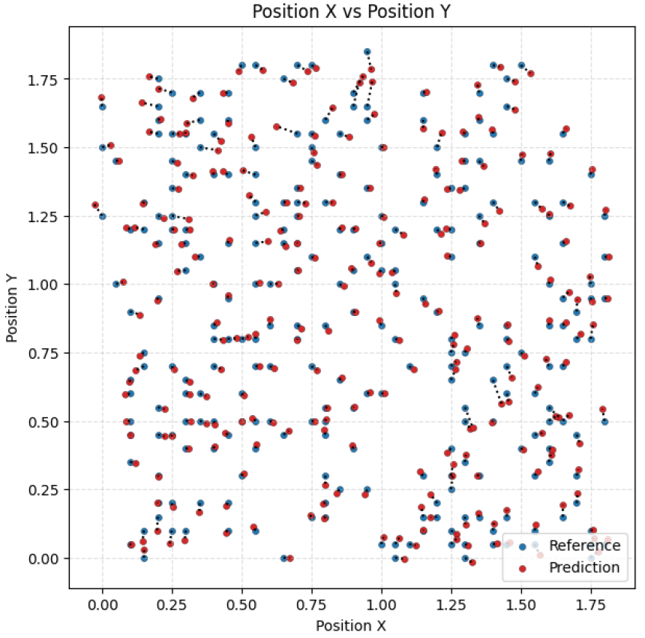
Figure 27 - Example of expected test results (2D positioning case)

Integration Roadmap

Introduction
In order to prepare for the main Integration Roadmap, there are two main preparatory activities that are being performed in Brunel University
- Measuring the Received Signal Strength of a LiFi Max system
- Measuring the TDoA from a 5G sub-6GHz

Measuring the Received Signal Strength of a LiFi Max system
1. Remove any Adaptive Gain Control (AGC) that is adaptively modifying the transmit signal strength
2. Split the received signal from the OWC Antenna using a RJ45 2 way Female splitter to allow
connection to both G.vlc access as well as the RSS measuring point using an electronic interface board.
3. Save the measured data using an oscilloscope to a USB drive and analyse its accuracy
4. Amplify the mVolt range signal by 60dB to be a Volt range signal
5. Analog to Digital convert the received signal and validate its accuracy with the captured data
6. Process the digital signal to remove any reference signals and compute the average signal strength
7. Perform RSS localisation test

Once this has been completed then the LiFi OWC antennas can be replaced with the 5G OWC antennas with the up/down frequency converters and the RSS localisation test repeated.

Measuring the TDoA from a 5G sub-6GHz system
1. Upgrade the 5G system at Brunel to do sub-6 GHz localisation test:
•Upgrade the base station:
    - Remove embedded antenna,
    - Install 4 x antenna cables extensions,
    - Install external antennas at the room corners.

2- Upgrade Server software (?) (SW) (CU + DU + Core) to include localisation SW (remote upgrade).
3- Use UE (Telit) that has supports Sounding Reference Signal (SRS).
4- Add Laptop with SW to display localisation results
5- Perform TDoA localisation test
Once this has been completed then the 5G sub-6 GHz antennas can be replaced with the OWC antennas with their up/down converters and the TDoA localisation test repeated, as illustrated on Figure 28.
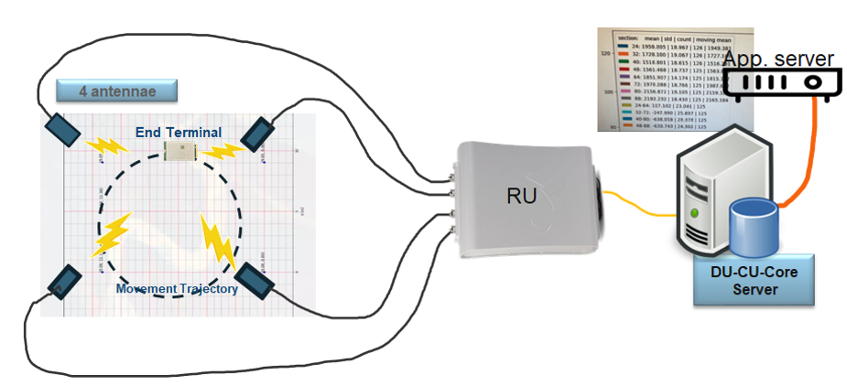
Figure 28 - Sub-6Gz or OWC TDoA localisation test.

Integration Roadmap
In order to validate experimentally the OPTI-6G system, we intend to follow the integration and test plan schedule shown in Figure 9.
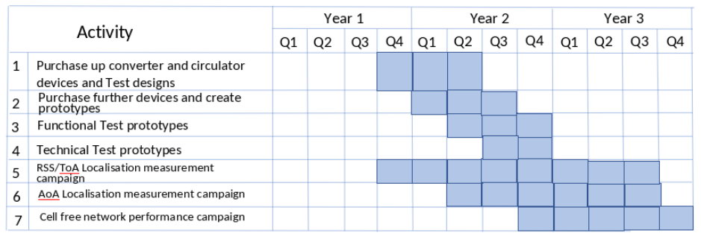
Figure 29 - Integration and test plan schedule
A critical aspect in the development of the OPTI-6G system is the interface between the 3.5 GHz RU and the optical antennas, which requires up/down conversion of the signal between baseband and 3.5 GHz. Initially, the up/down converter and circulator necessary to perform this operation will be purchased and tested on a single set of components to test if it works functionally and technically (see line (1) in Figure 29). Once this has been established, then further converters and circulators will be purchased (2) and final functional (3) and technical tests (4) performed.
At this point, RSS and TOA localisation measurement campaign can then proceed to be performed (5), before proceeding onto making enhancements and performing the beamsteering-based localisation measurement campaign (6). Finally, the cell-free network enhancements can be tested in cell-free network performance campaign (7). Note the cell free network functionality depends on the synchronisation of the transmission from the two RU transmission points, which is ongoing enhancement to the RunEL DU and RU networks. Since there are two access points in Brunel University’s 5G network, cell-free access will be tested between the OWC access points from each of the two cell-free access networks.

Summary and Conclusions
This document has provided a structured and detailed framework for the experimental validation of the Cell-Free Optical Wireless Communication (OWC) system as part the Opti-6G project, focusing on both communication and localisation functionalities. Through the design of dedicated test beds and clearly defined procedures, the methodology ensures accurate and consistent measurement of performance against the KPIs established in earlier phases of the project. The proposed set-ups not only facilitate a reliable assessment of system capabilities in controlled environments but also serve as a foundation for scalable validation in future deployment scenarios. These efforts collectively contribute to the broader objectives of WP3 and WP4 by enabling systematic and reproducible evaluation of the OWC CFN architecture.

References

- [1] A. Mahbas, J. Cosmas, S. Mueen and J. Wang, "LOS Analysis for Localisation in High Frequency Systems," in IEEE Transactions on Wireless Communications, vol. 23, no. 6, pp. 6425-6437, June 2024.
- [2] A. Mahbas, J. Cosmas and H. Al-Raweshidy, "Distance Analysis in Regular OWC Deployments," in IEEE Access, vol. 12, pp. 186803-186818, 2024.
- [3] “LIFIMAX Technical Document”, Oledcomm, Vélizy-Villacoublay, France, 2024, Accessed Octobre 2024.
- [4] “RF 1:1 Flux Coupled Transformer 0.3 -200 MHz Electrical Specifications: Freq. = 0.3 -200 MHz, T A = 25°C, P in = 0 dBm Features.” Accessed: Aug. 20, 2024. [Online]. Available: https://cdn.macom.com/datasheets/MABAES0060.pdf.
- [OLE24] Oledcomm, “LiFi Technology : Unleashing the Power of Light for Enhanced Connectivity,” www.oledcomm.net (accessed Dec. 20, 2022).
- [OPT24b] OPTI-6G, “D3.1: Near IR Cell Free Communication System Design,” Report deliverable, Dec. 2024.
- [OPT24c] OPTI-6G, “D4.1: OWC Localisation Sensing System Design,” Report deliverable, Dec. 2024.

